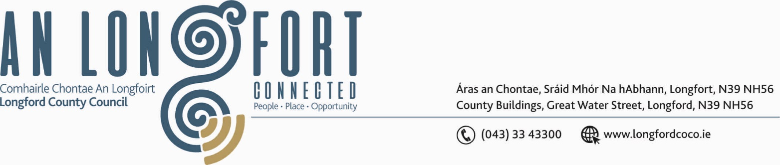

BALLYMAHON MUNICIPAL DISTRICT

18th January 2019.

To: Each Member of Ballymahon Municipal District.

Dear Member,

You are requested to attend Meeting of Ballymahon Municipal District to be held in Ballymahon Community Library on Thursday, 24th January 2019 at
4.30 p.m. to transact business, as set out on the Agenda hereunder.

Yours sincerely,
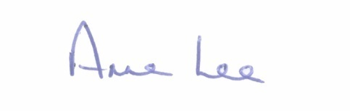

_______________
Anne Lee,
Meetings Administrator.

AGENDA

Prayer before meeting.

1. Confirmation of Minutes of the following Meetings of Ballymahon Municipal District -

- Municipal District Committee Meeting held on the 19th December 2018
- Municipal District December Meeting held on the 19th December 2018.
copies enclosed.

2. Matters arising from Minutes.

3. Management Report - enclosed.

4. Consideration of Adoption of Part 8 Report (Planning and Development Act 2000 (as amended) and Planning and Development Regulations 2001) (as amended) in respect of the construction of c.2.32 km path linking Ballymulvey to Newcastle Woods - details attached.

5. Consideration and adoption of Draft Municipal District Report for inclusion in Longford County Council 2018 Annual Report - enclosed.

6. Consideration of Nominee for the 2019 Cathaoirleach Awards.

7. Notices of Motions submitted by Councillors, as listed hereunder –

Councillor Paul Ross.

“That the white line on the R392 at Lisaniskey / Terlicken Ballymahon be extended towards Ballymahon by 100m to end east of the junction in the interest of public safety.”

“That the caravans currently parked in Mostrim Oaks, Edgeworthstown be removed.”

::::::::::::::::::::::::::

